1st. Register for IBM Cloud Lite.

Please head to [www.ibm.com/cloud](http://www.ibm.com/cloud) then click **Cloud sign-up/log in** from upper right corner.

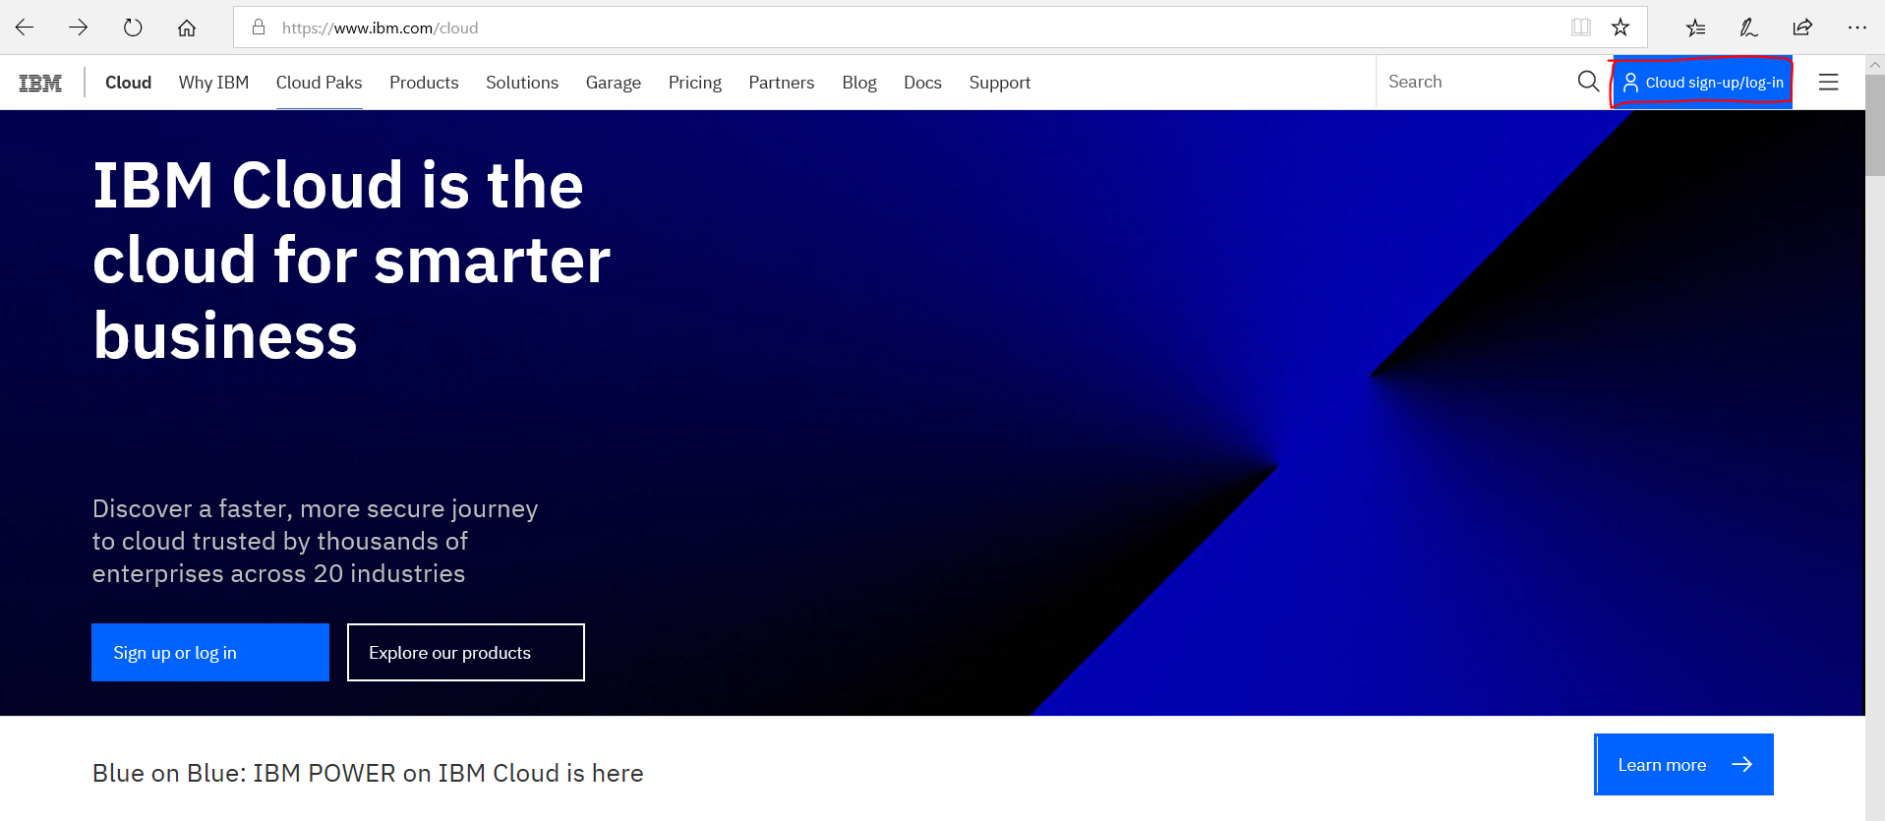

After your registration. Please head to IBM cloud Catalog.

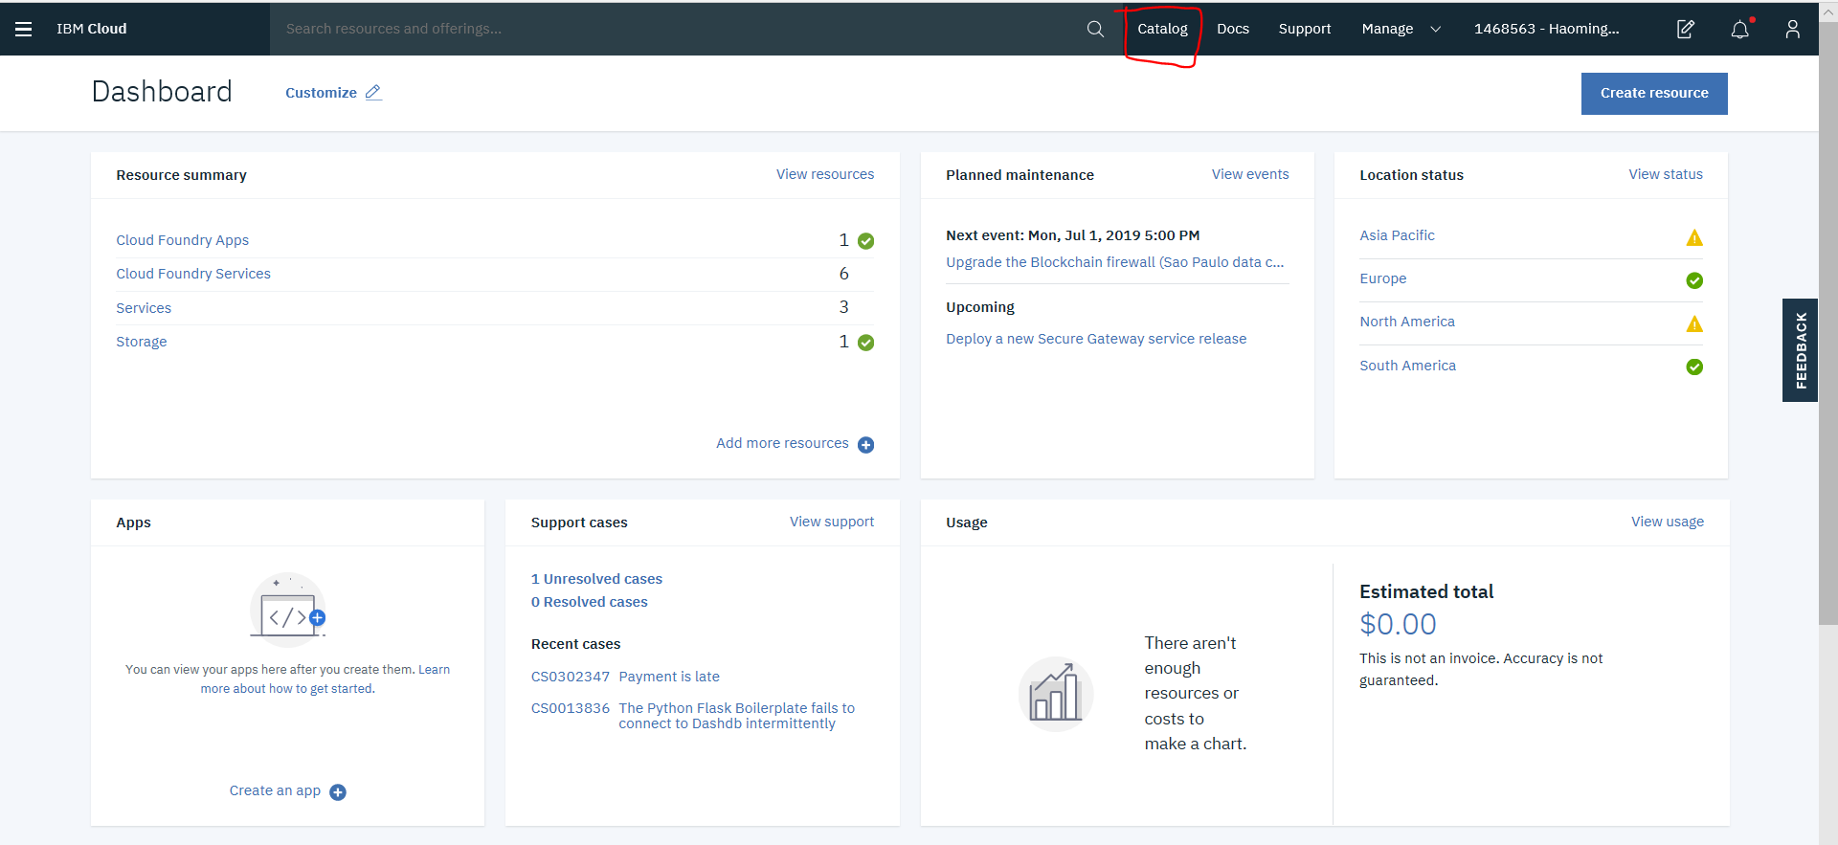

Type **Watson** in the search box. Watson Studio and Watson Machine Learning are 2 major components will be used during the workshop.

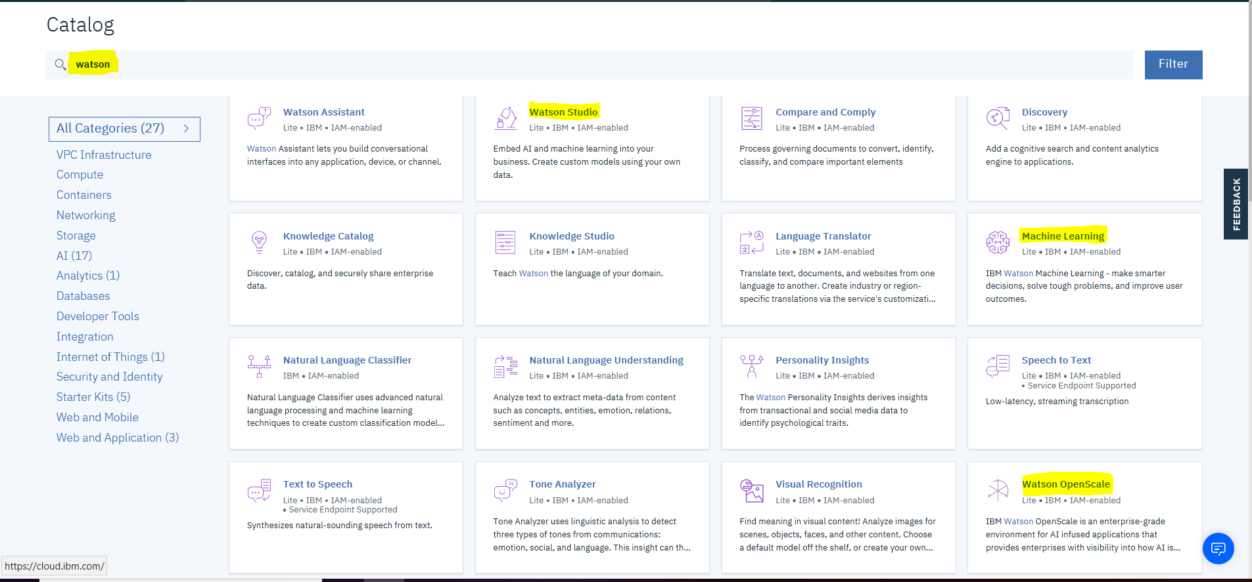

Please choose Lite plan for all 3 service you need.

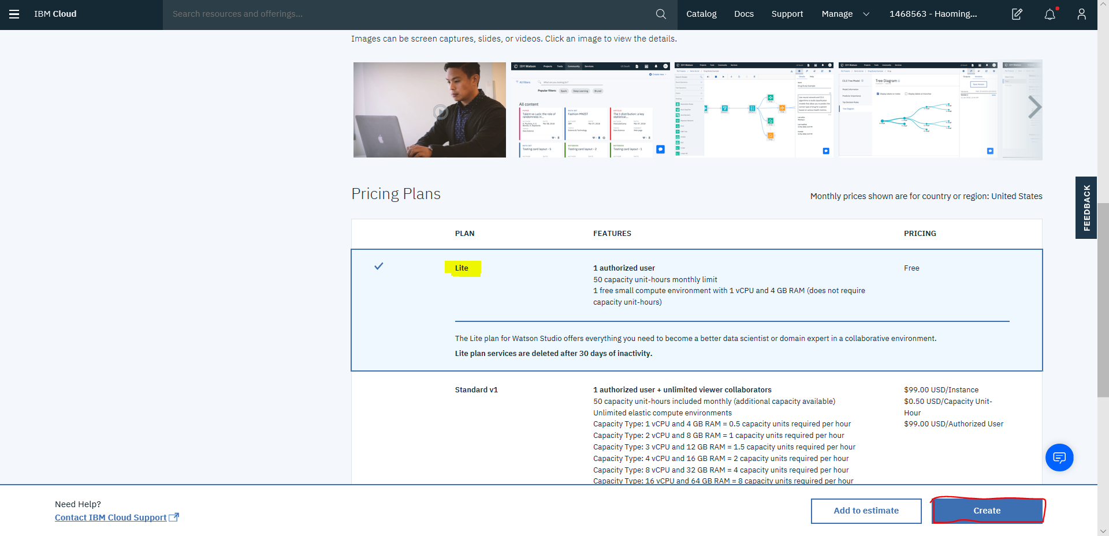

If you click on View resources from Dashboard page.

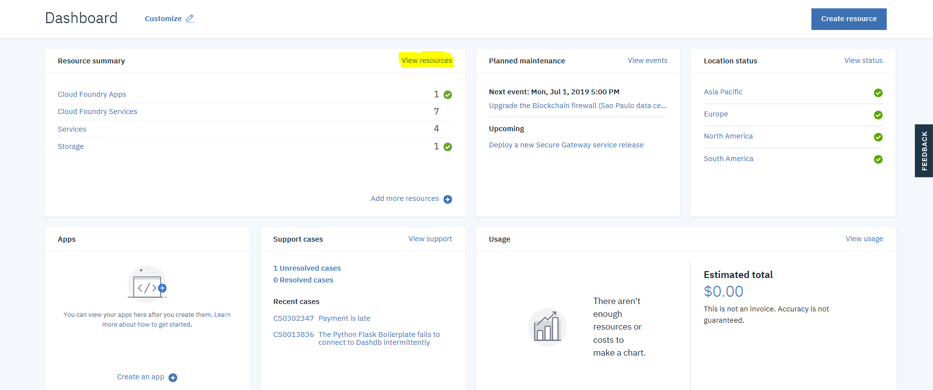

You should be able to see those service.

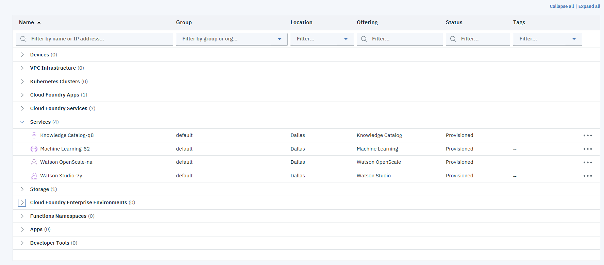

Click on Watson Studio. Then click **Get Started.** You should be able to access Watson Studio now.

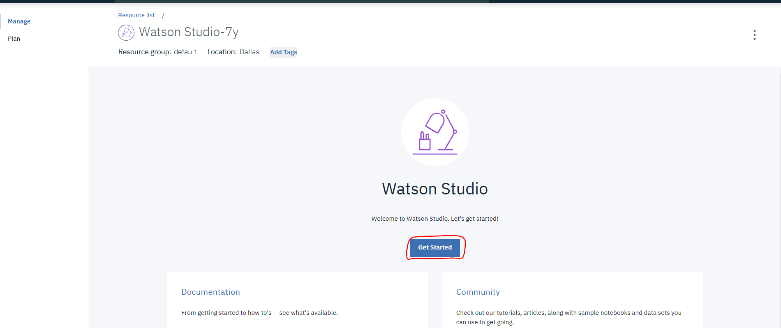

2nd. Register Decision Optimization on Cloud. Please head to

<https://www.ibm.com/us-en/marketplace/decision-optimization-cloud>

Then click on Try Free Edition. Which will give you 30 days trial.

You can use the same IBM account registered for IBM cloud to log in.

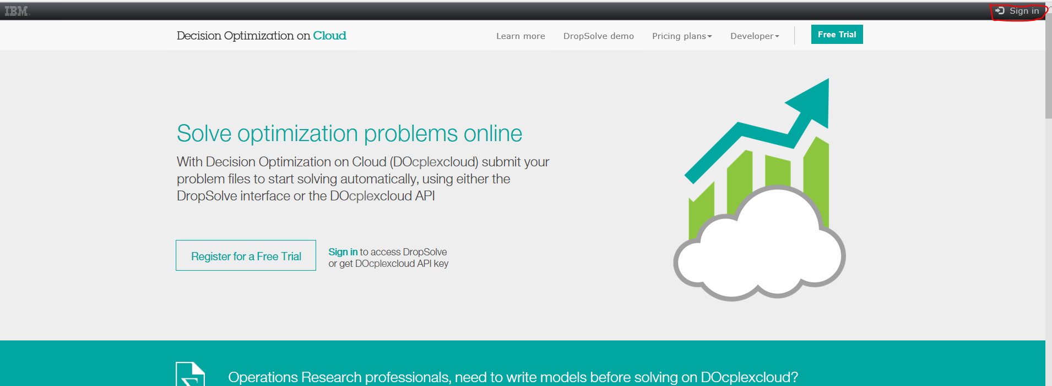

Click to **Sign-in** from up-right corner. Use your IBM Account.

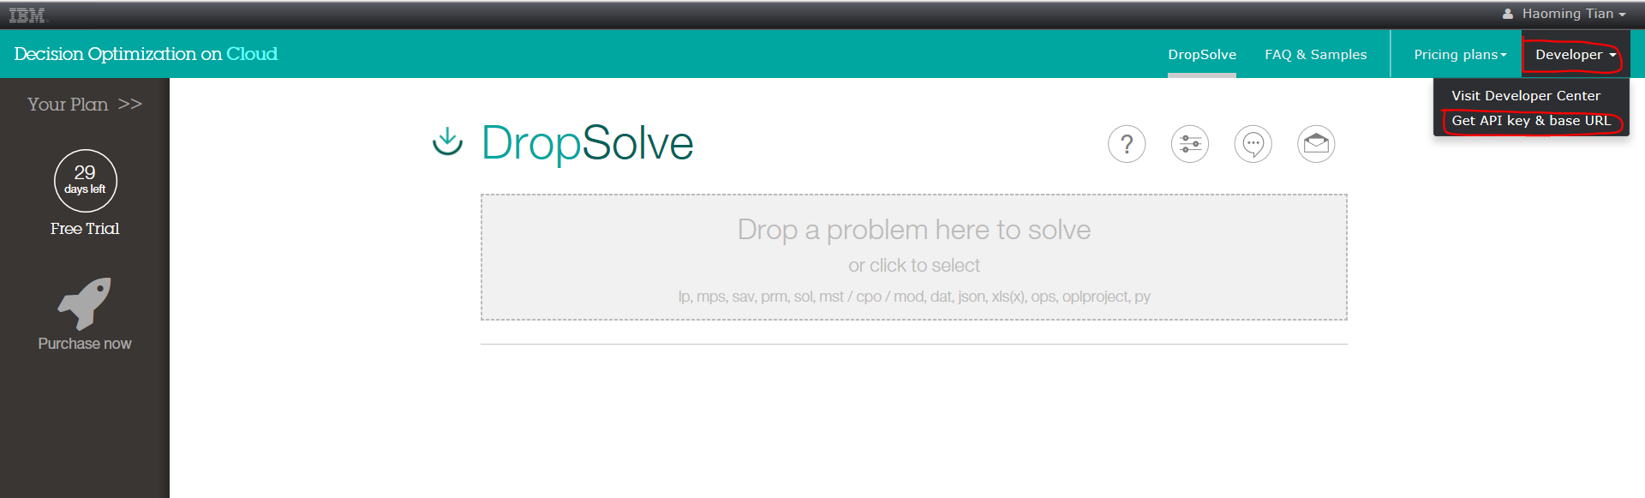

Under **Developer** tab, choose Get API key & base url. Then click generate API key. You should be able to see an API key generated there. We’ll use that later.

